**1.Creating A visualForce Page.**

<apex:page standardController="Account">

<apex:form >

<apex:pageBlock >

<apex:pageBlockButtons >

<apex:commandButton action="{!quicksave}" value="Save" rerender="out,in" status="Status"/>

</apex:pageBlockButtons>

<apex:pageBlockSection title="Account Information">

<apex:inputField value="{!account.name}"/>

<apex:inputField value="{!account.accountnumber}"/>

<apex:inputfield value="{!account.rating}"/>

<apex:inputfield value="{!account.industry}"/>

</apex:pageBlockSection>

<apex:pageBlockSection title="Category Information">

<apex:inputField value="{!account.type}"/>

<apex:inputfield value="{!account.annualrevenue}"/>

</apex:pageBlockSection>

</apex:pageBlock>

</apex:form>

<apex:pageBlock id="out" >

<apex:actionStatus startText="Saving..." id="status"></apex:actionStatus>

</apex:pageBlock>

</apex:page>

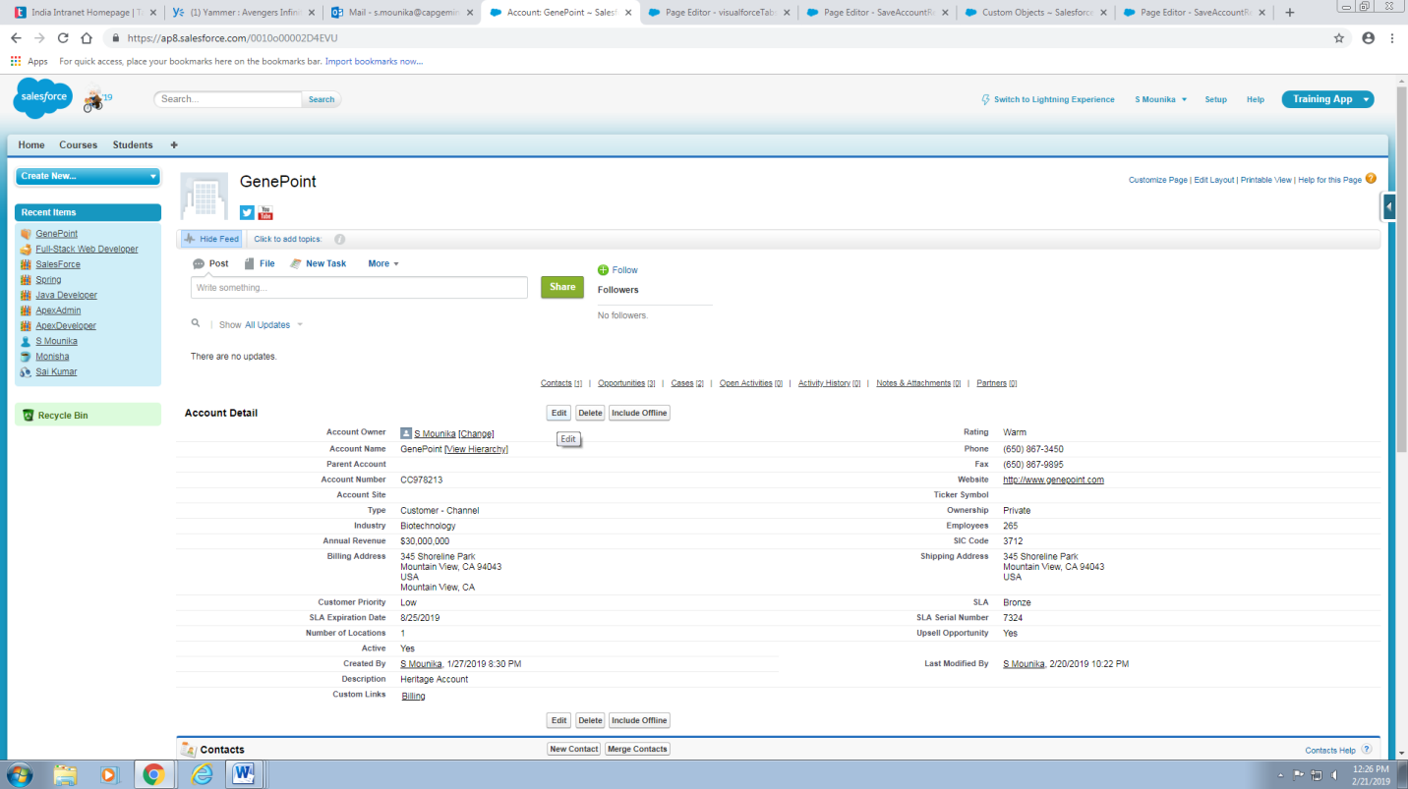

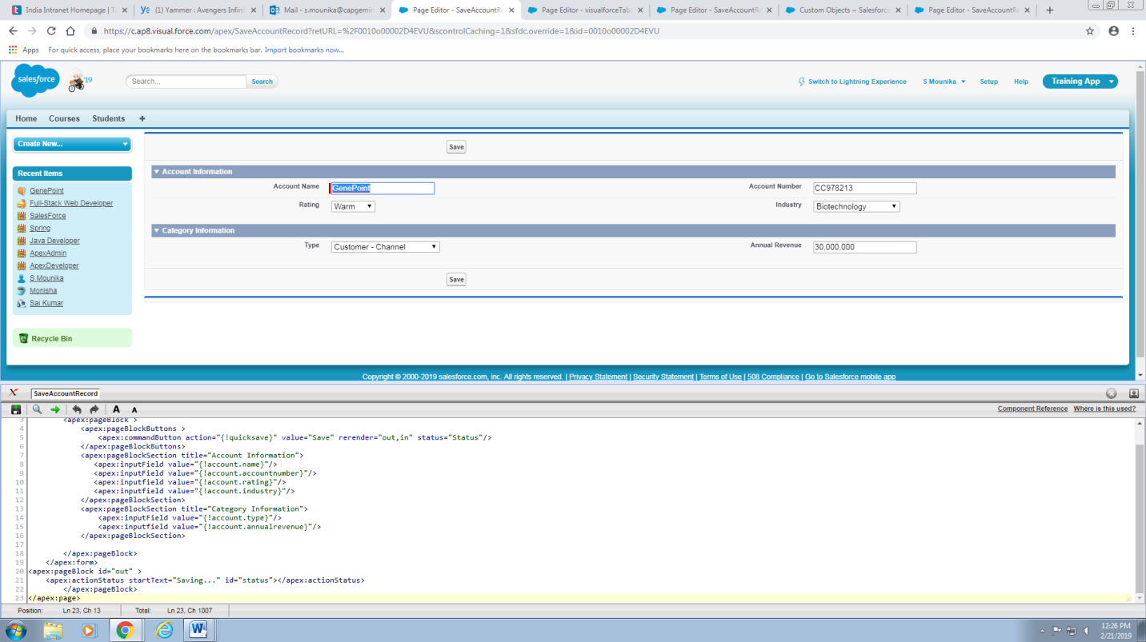

**2.Create a tabbed visualforce page which have Position Details**

<apex:page standardController="Position__c" tabStyle="Position__c">

<apex:tabPanel >

<apex:tab title="Position Details" label="Position Details">

<apex:detail relatedList="false"/>

</apex:tab>

<apex:tab title="Job Applications" label="Job Applications">

<apex:relatedList subject="{!Position__c}" list="Job_Applications__r"/>

</apex:tab>

<apex:tab title="Candidates" label="Candidates">

<apex:relatedList subject="{!Position__c}" list="Candidates__r"/>

</apex:tab>

</apex:tabPanel>

</apex:page>

**POSITION DETAILS TAB**

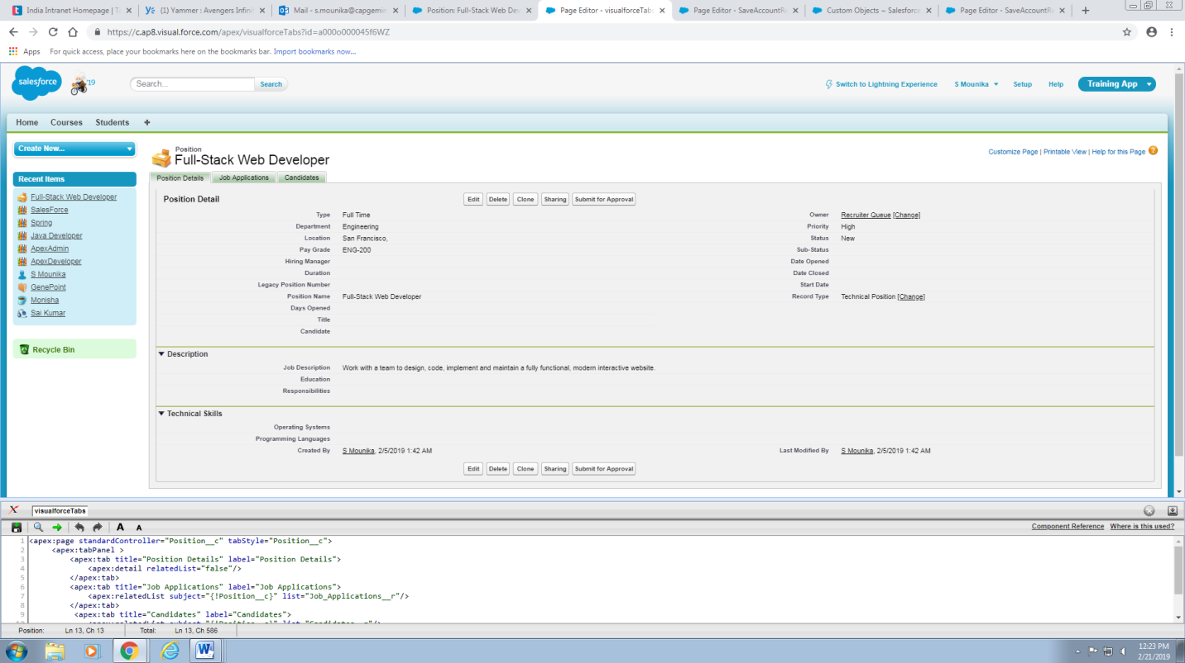

**JOB APPLICATIONS TAB**

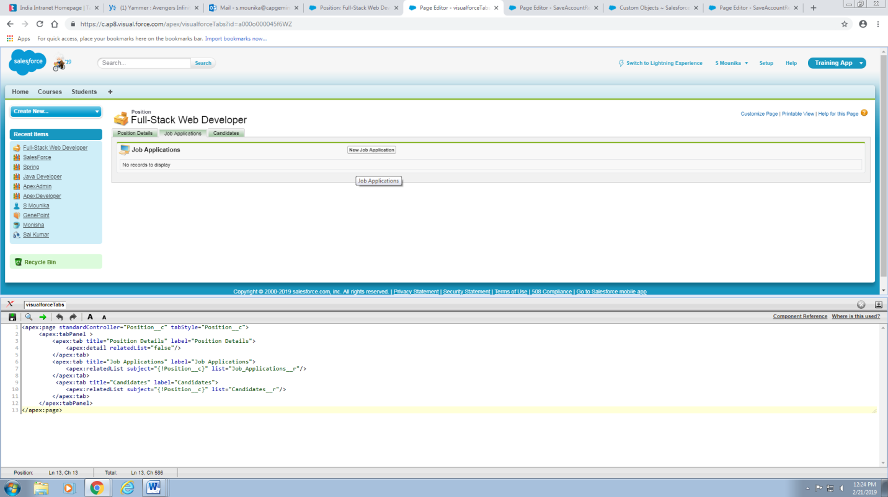

**CANDIDATES TAB**

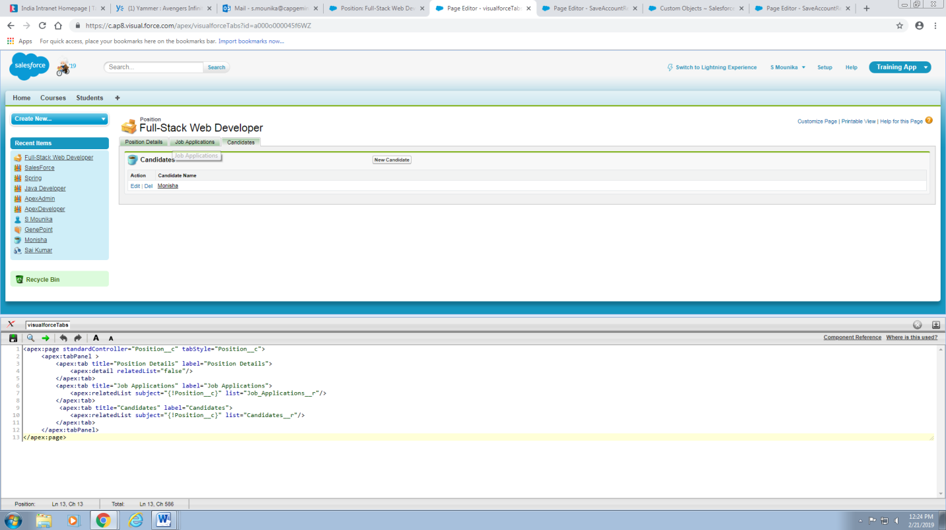

**3.Create Training App with Two objects-Student and course**

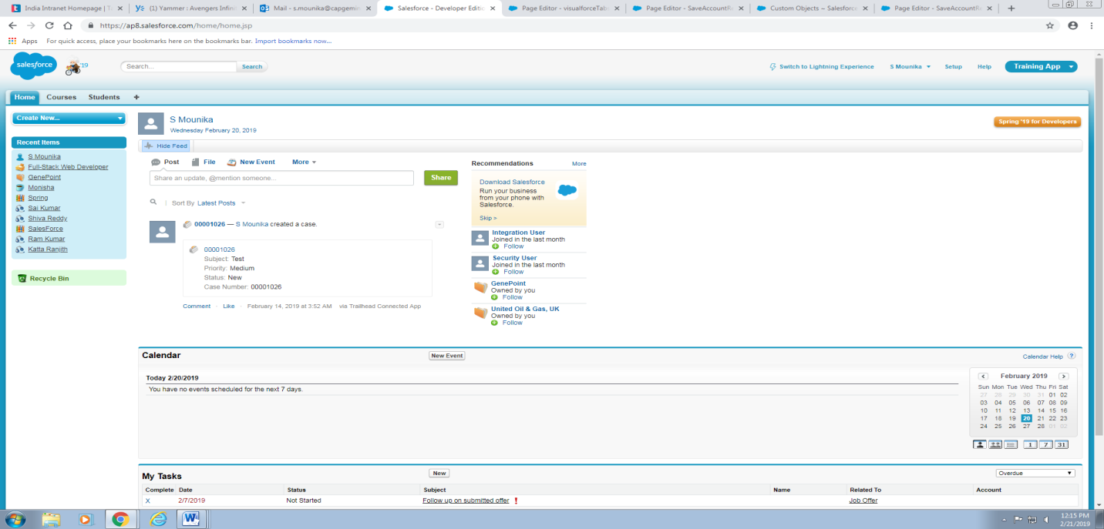

**3.1 Entering Courses and students**

Course__c c1=new Course__c();

c1.name='ApexDeveloper';

c1.APEX_Course_Name__c='ApexDeveloper';

c1.Apex_Credits__c=5;

c1.Apex_External_ID__c='1000';

insert(c1);

Student__c s1=new Student__c();

s1.name='Mounika Reddy';

s1.APEX_First_name__c='Mounika';

s1.APEX_Last_name__c='Reddy';

s1.Apex_course__c=c1.id;

s1.Apex_Marks__c=80;

s1.Apex_Result__c='Pass';

insert(s1);

Student__c s2=new Student__c();

s2.name='Narmada Akula';

s2.APEX_First_name__c='Narmada';

s2.APEX_Last_name__c='Akula';

s2.Apex_course__c=c1.id;

s2.Apex_Marks__c=75;

s2.Apex_Result__c='Pass';

insert(s2);

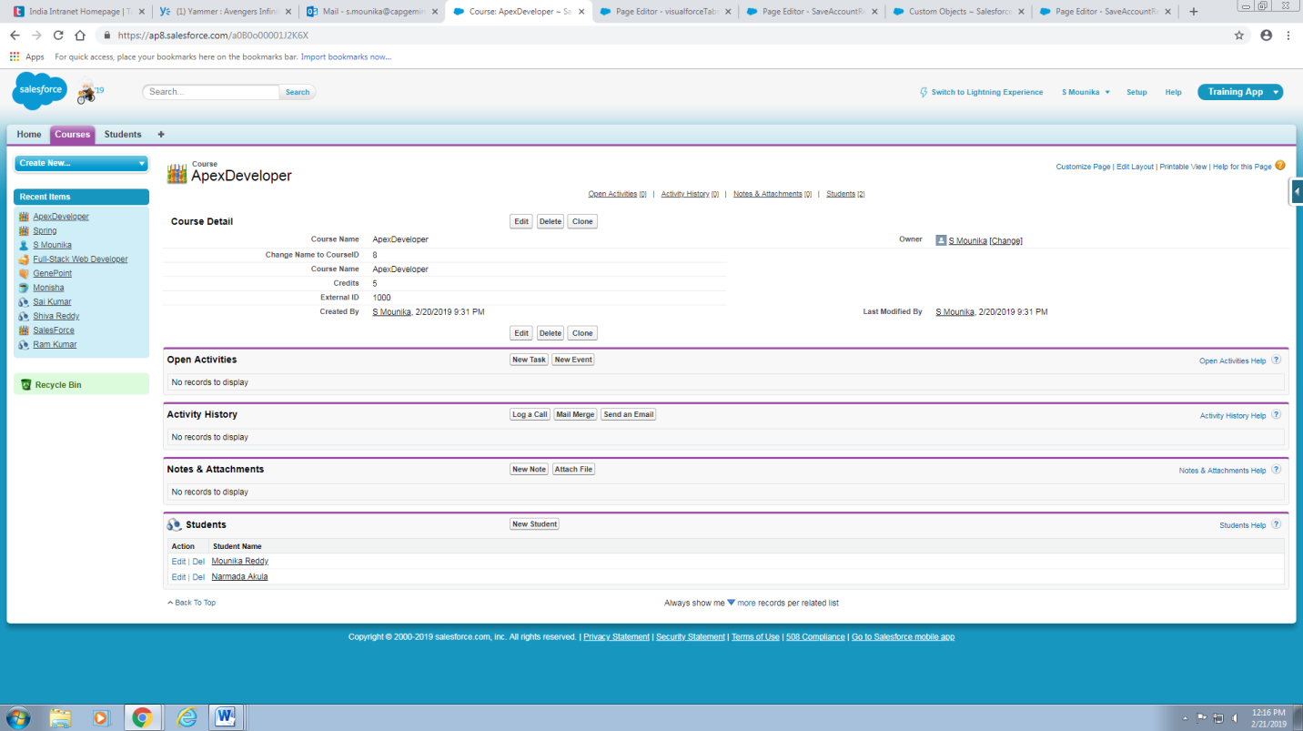

Course__c c2=new Course__c();

c2.name='ApexAdmin';

c2.APEX_Course_Name__c='ApexAdmin';

c2.Apex_Credits__c=4;

c2.Apex_External_ID__c='1001';

insert(c2);

Student__c s1=new Student__c();

s1.name='Kanaka Pushpa';

s1.APEX_First_name__c='Kanaka';

s1.APEX_Last_name__c='Pushpa';

s1.Apex_course__c=c2.id;

s1.Apex_Marks__c=80;

s1.Apex_Result__c='Pass';

insert(s1);

Student__c s2=new Student__c();

s2.name='Sekhar Reddy';

s2.APEX_First_name__c='Sekhar';

s2.APEX_Last_name__c='Reddy';

s2.Apex_course__c=c2.id;

s2.Apex_Marks__c=89;

s2.Apex_Result__c='Pass';

insert(s2);

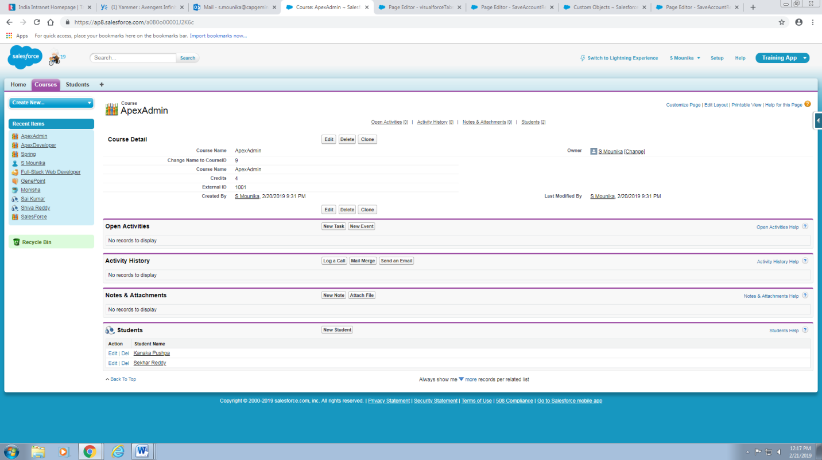

Course__c c3=new Course__c();

c3.name='Java Developer';

c3.APEX_Course_Name__c='Java Developer';

c3.Apex_Credits__c=6;

c3.Apex_External_ID__c='1002';

insert(c3);

Student__c s1=new Student__c();

s1.name='Sai Shiva';

s1.APEX_First_name__c='Sai';

s1.APEX_Last_name__c='Shiva';

s1.Apex_course__c=c3.id;

s1.Apex_Marks__c=80;

s1.Apex_Result__c='Pass';

insert(s1);

Student__c s2=new Student__c();

s2.name='Ram Sai';

s2.APEX_First_name__c='Ram';

s2.APEX_Last_name__c='Sai';

s2.Apex_course__c=c3.id;

s2.Apex_Marks__c=45;

s2.Apex_Result__c='Fail';

insert(s2);

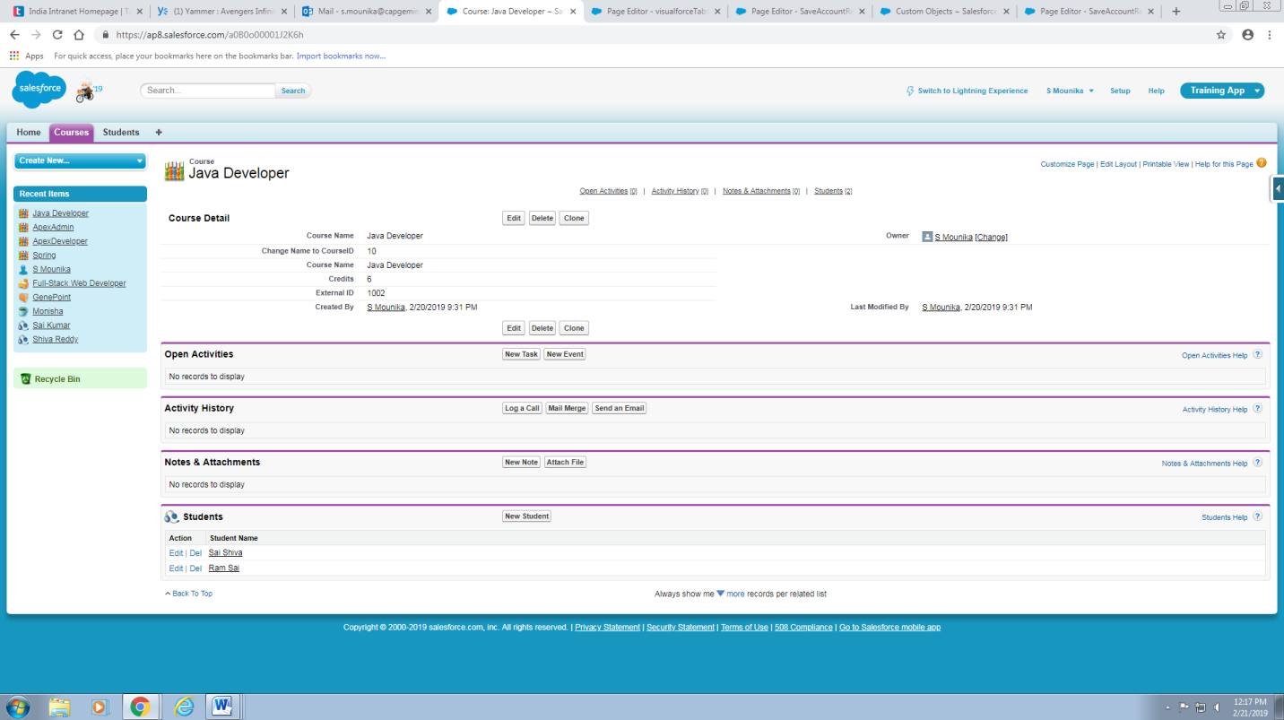

Course__c c4=new Course__c();

c4.name='Spring';

c4.APEX_Course_Name__c='Spring';

c4.Apex_Credits__c=6;

c4.Apex_External_ID__c='1003';

insert(c4);

Student__c s1=new Student__c();

s1.name='Katta Ranjith';

s1.APEX_First_name__c='Katta';

s1.APEX_Last_name__c='Ranjith';

s1.Apex_course__c=c4.id;

s1.Apex_Marks__c=80;

s1.Apex_Result__c='Pass';

insert(s1);

Student__c s2=new Student__c();

s2.name='Ram Kumar';

s2.APEX_First_name__c='Ram';

s2.APEX_Last_name__c='Kumar';

s2.Apex_course__c=c4.id;

s2.Apex_Marks__c=70;

s2.Apex_Result__c='Pass';

insert(s2);

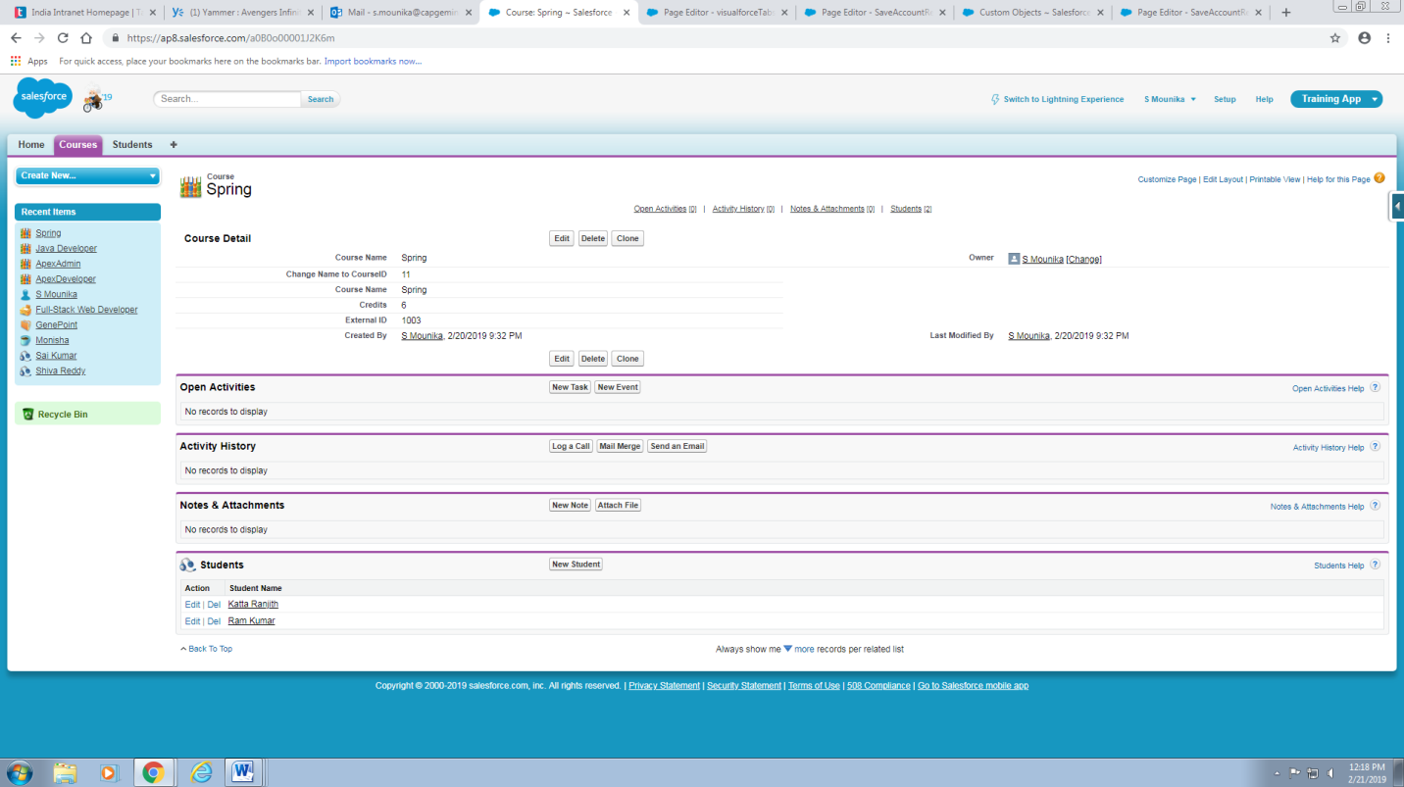

Course__c c5=new Course__c();

c5.name='SalesForce';

c5.APEX_Course_Name__c='SalesForce';

c5.Apex_Credits__c=9;

c5.Apex_External_ID__c='1005';

insert(c5);

Student__c s1=new Student__c();

s1.name='Shiva Reddy';

s1.APEX_First_name__c='Shiva';

s1.APEX_Last_name__c='Reddy';

s1.Apex_course__c=c5.id;

s1.Apex_Marks__c=80;

s1.Apex_Result__c='Pass';

insert(s1);

Student__c s2=new Student__c();

s2.name='Sai Kumar';

s2.APEX_First_name__c='Sai';

s2.APEX_Last_name__c='Kumar';

s2.Apex_course__c=c5.id;

s2.Apex_Marks__c=89;

s2.Apex_Result__c='Pass';

insert(s2);

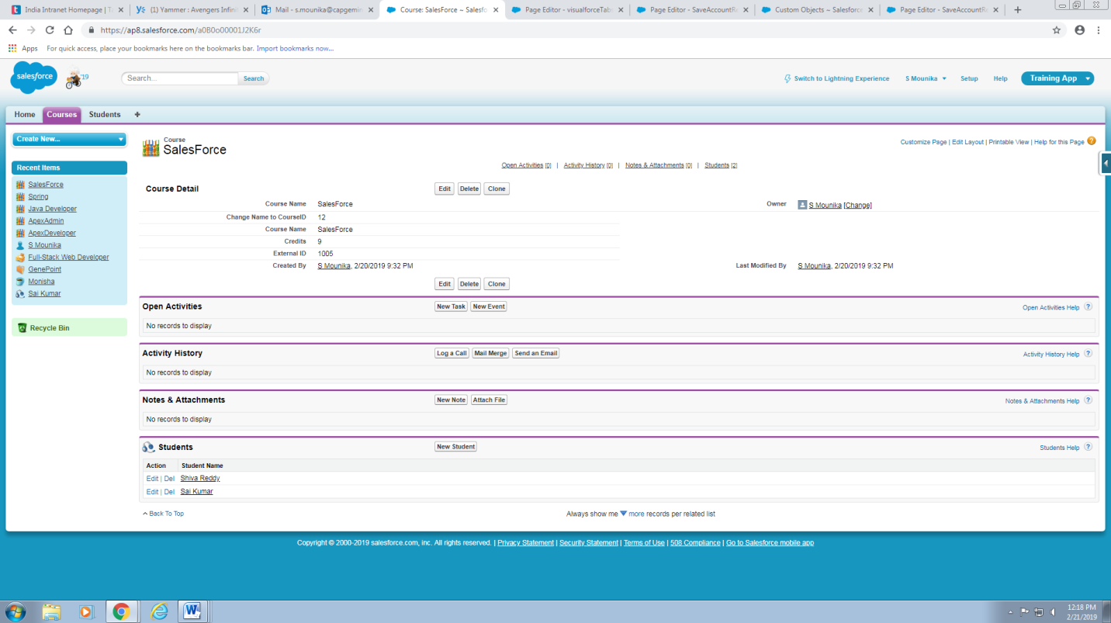

**3.2 Display List Of Courses**

List<Course__c> CrseList=[SELECT c.APEX_Course_name__C from Course__c c];

System.debug(CrseList);

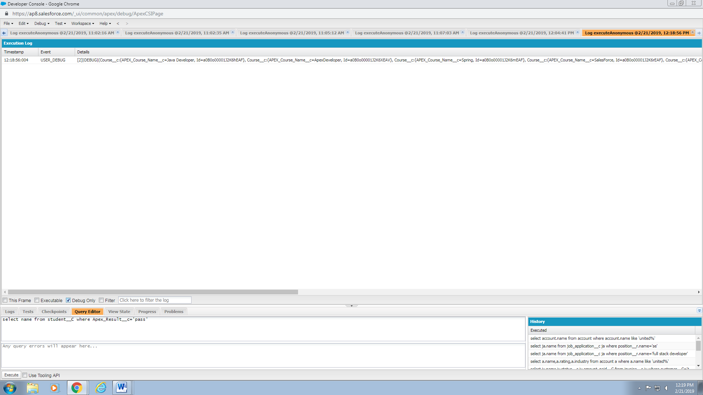

**3.3 Display List of students who passed and failed**

List<student__c> Pass=[select name from student__C where Apex_Result__c='pass' ];

System.debug('Passed Students');

System.debug(Pass);

List<student__c> Fail=[select name from student__C where Apex_Result__c='Fail' ];

System.debug('Passed Students');

System.debug(Fail);

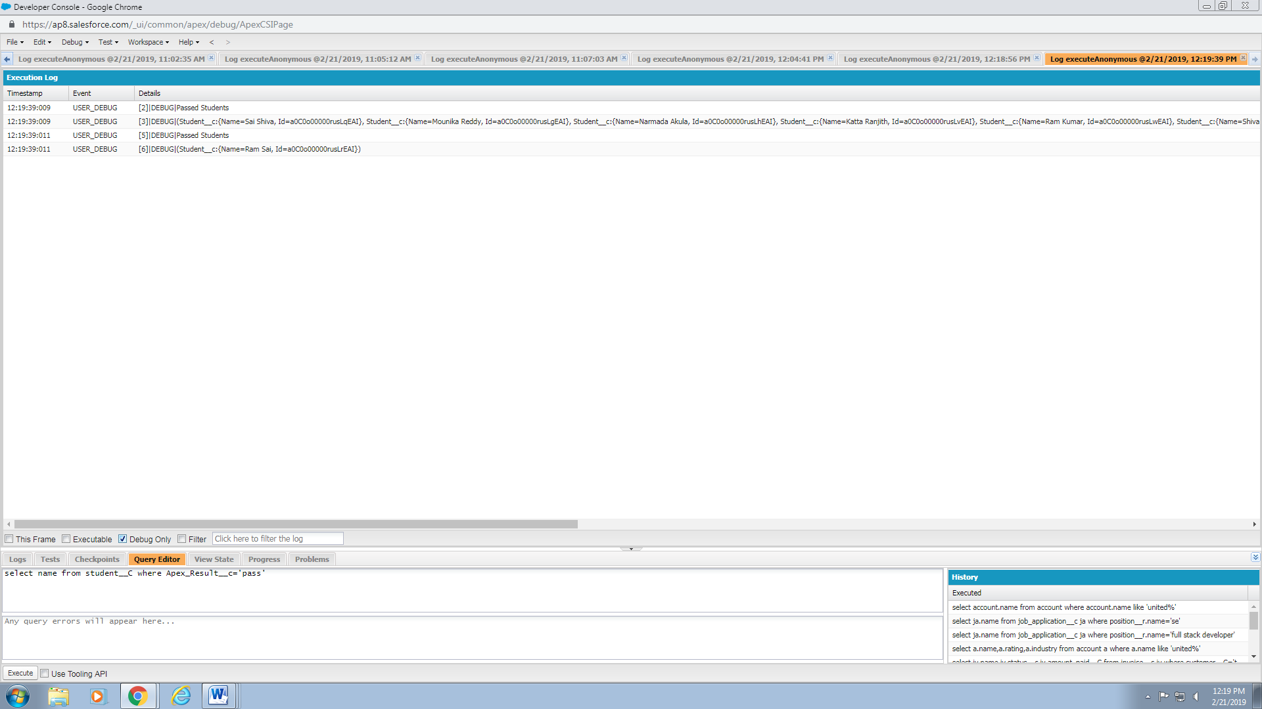

**3.4 Write SOSL Query to display Apex Courses**

List<List<sObject>> objList=[FIND 'Apex*' IN Name Fields Returning Course__c(name)];

System.debug(objList);

